MD. Rajaul Ansari

## **Importing and Using Functions**

Task:

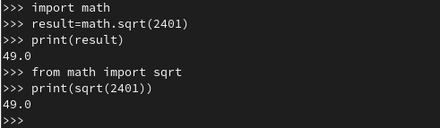

Task:

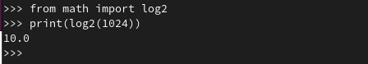

## **Defining Functions**

Task:

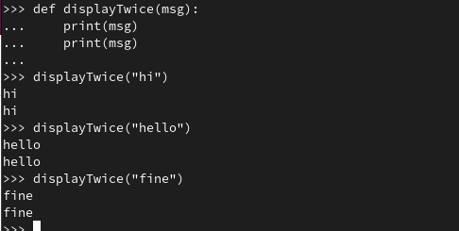

**Docstrings**

Task:

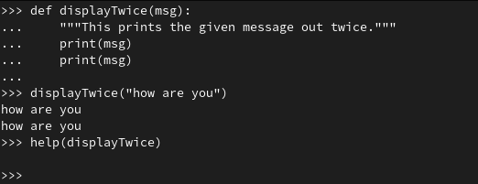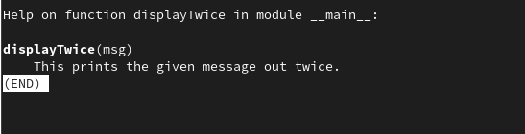

**Returning a value**

Task:

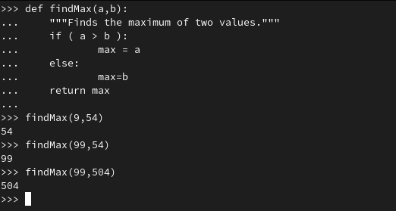

## **Default Arguments**

Task:

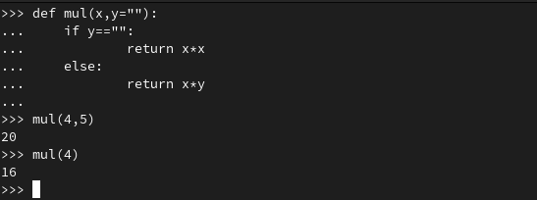

KEYWORD ARGUMENTS:

Task:

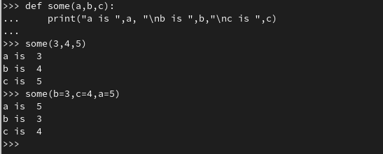

Task:

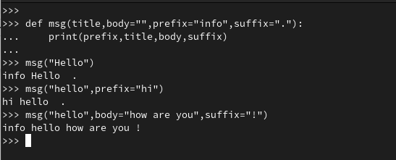

## **Arbitrary Length Argument Lists**

Task:

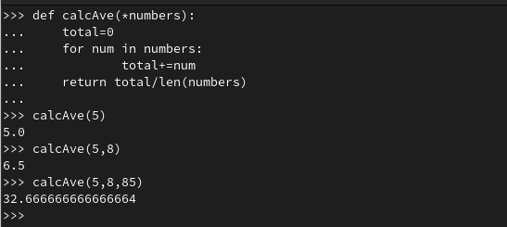

## **Lambda Expressions**

Task:

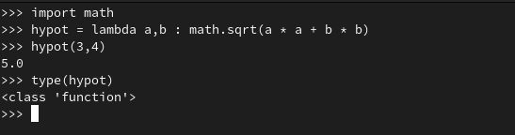

Task:

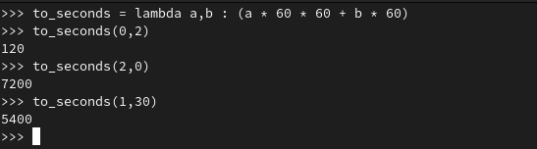

Task:

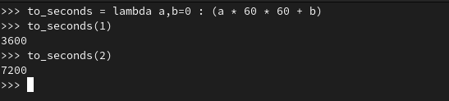

## **Key Terminology**

**→Module:**A Python module is a file containing Python definitions and statements.

**→The Python Standard Library:** The Python Standard Library is a collection of script modules accessible to a Python program to simplify the programming process and remove the need to rewrite commonly used commands.

**→Formal Parameters:**Parameter Written in Function Definition is Called “Formal Parameter. Formal parameters are always variables.

**→Actual Parameters (argument values):**Parameter Written in Function Definition is Called Actual Parameter. Actual parameters do not have to be variables.

**→Default and Keyword Arguments:** Default arguments are keyword arguments whose values are assigned at the time of function definition.

**→Lambda Expression:** A lambda expression is a short block of code which takes in parameters and returns a value. Lambda expressions are similar to methods, but they do not need a name and they can be implemented right in the body of a method.